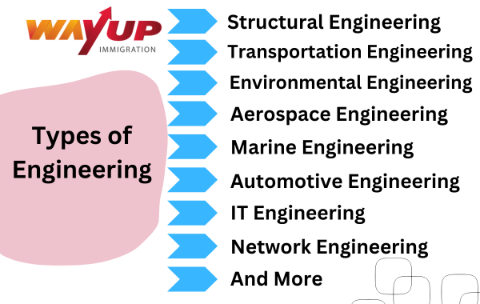

Structural Engineers



Structural engineers ensure that buildings and bridges are built to be strong enough and stable enough to resist all appropriate structural loads (e.g., gravity, wind, snow, rain, seismic (earthquake), earth pressure, temperature, and traffic) to prevent or reduce the loss of life or injury.

Transportation Engineer

Transportation engineering is a broad field that can apply to work with roadways, waterways, railways and other projects. These engineers develop faster, safer and more efficient means of transportation that ensure they're safe for people using them.

# ENVIRONMENTAL ENGINEERING

Environmental engineers seek solutions to environmental challenges that impact the health and well-being of society and the environment. The technical skills environmental engineers learn are used to develop strategies and technologies to treat and protect the quality of air, water and earth. Environmental engineers also address emerging global challenges such as the impact of climate change on communities and ecosystems. The Zachry Department of Civil & Environmental Engineering is dedicated to equipping students with the skills to be future leaders in this discipline.

# Aerospace Engineering

# What is Aeronautical Engineering? (A Complete Guide) - TWIAerospace engineers develop leading-edge technologies and integrate them into aerospace vehicle systems used for transportation, communications, exploration, and defense applications. This involves the design and manufacturing of aircraft, spacecraft, propulsion systems, satellites, and missiles, as well as the design and testing of aircraft and aerospace products, components, and subassemblies.

Marine engineering

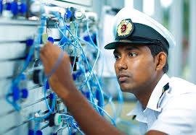A. Marine engineers are involved with the design, construction, installation, operation, maintenance and repair of the main propulsion engines and auxiliary machinery and systems found in all kinds of ships, boats and offshore installations.

Automotive engineering

Automotive engineering is one of the most sophisticated courses in engineering which involves design, manufacturing, modification and maintenance of an automobile such as buses, cars, trucks and other transportat

# Information Technology Engineering

IT engineers are those who design and implement computer hardware, software and networks. They are involved in the logical design of computers, how data is stored, transmitted and accessed by computers. They create the blueprints for software programs, which tell computers how to store, access and transmit data. IT Engineer are responsible for computer security, software development and network design. They often work with computer programmers, computer engineers and other technology professions.IT engineers may be employed by governmental agencies, large corporations, or by small businesses. Some IT engineers work for consulting firms, where they provide advice and design solutions to companies that need help with their technology.

Network engineering

Network engineering may refer to: The field concerned with internetworking service requirements for switched telephone networks. The field concerned with Computer Networking; the design and management of computer networks. Network engineers focus on delivering high-availability network infrastructure to sustain the users' online and on-site IT activities. Network engineers often overlap with other roles, such as computer network architects or security systems engineers, and work internally within an organization or as outside consultants.